**SET THEORY:**

Set theory is a branch of mathematical logic that deals with collections of distinct objects, called sets. It provides the foundation for many concepts in databases, probability, and programming.

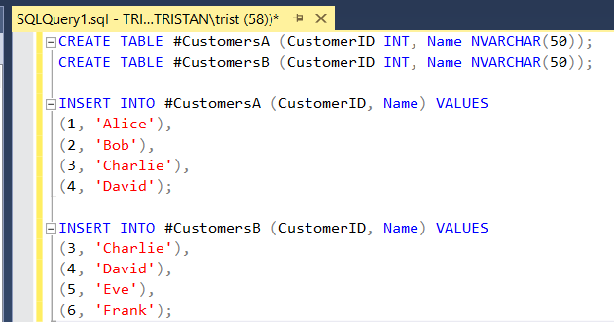For these examples, I’ve created a Temp Table CustomersA and CustomersB.

**UNION:**

Union (A ∪ B) – Elements in A or B

* Combines all unique elements from both sets.
* UNION removes duplicates.

SELECT CustomerId, Name

FROM #CustomersA

UNION

SELECT CustomerId, Name

FROM #CustomersB;

**INTERSECTION:**

Intersection (A ∩ B) – Elements in both A and B

* Returns only elements that exist in both sets.
* In SQL: INTERSECT finds common records.

SELECT CustomerId, Name FROM #CustomersA

INTERSECT

SELECT CustomerId, Name FROM #CustomersB;

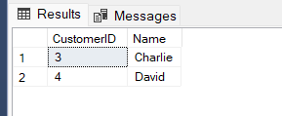

**DIFFERENCE:**

**Difference (A - B) – Elements in A but not in B**

* Finds elements that exist in A but not in B.
* In SQL: EXCEPT returns records in A but not in B.

SELECT CustomerId Name FROM #CustomersA

EXCEPT

SELECT CustomerId, Name FROM #CustomersB;

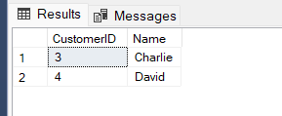

**SUBSET:**

Subset (A ⊆ B) – Checking if A is a subset of B

* A set A is a subset of B if every element in A is also in B.
* In SQL: Uses EXCEPT to check if any elements exist in A but not in B.

SELECT

CASE

WHEN NOT EXISTS (

SELECT CustomerID FROM #CustomersA

EXCEPT

SELECT CustomerID FROM #CustomersB

) THEN 'A is a subset of B'

ELSE 'A is NOT a subset of B'

END AS Result;

